who are we targetting?

what subject **Math**

what year level **Year 9, regular classes (non extension)**

what highschool **Rangitoto College, year 9 maths classes**

what exactly are you going to do?

1. **what questions?**
   1. <https://nces.ed.gov/timss/released-questions.asp> Grade 8 set from 2011, 2007, 2003
   2. **question set** (1 or more question set), with difficulty associated with it
2. **how’s this going to be a study?**
   1. Option 1: Each participant takes both FL test and CAT, but two randomised groups where one group does FL first and the other does CAT first
      1. Time constraint for FL, around 30 questions, 45 minutes
      2. Distribution of questions domain, approx even number of questions from each topic and range of difficulty
      3. Test design:
         1. FL test
            1. time: 45 minutes
            2. 30 questions, each question has equal weighting
            3. 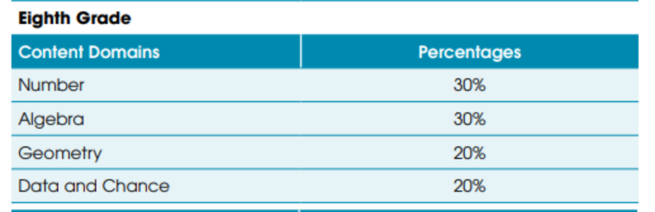
         2. CAT (MST) test
            1. MST because we want to control domain distribution and have research contribution.
            2. 2 stages, initial stage has 1 test, branches into 3 tests (easy, medium, hard). Both tests are the same length
            3. Assume 1.5 minutes for each question
            4. 10 questions for each stage, each question weighted depending on difficulty (difficulty based on the proportion of correct answers based on TIMSS study) - 15 minutes
            5. Same distribution of question topics as FL
      4. Test location & timing
         1. When? Lunch time pref (to not intrude on classroom time). Over two days
         2. Location: in desk separated class rooms
         3. With: computer (same interface for both FL and CAT)
         4. 20-30 people
            1. YuCheng - can people be from unspecified multiple classes? and if not, do we need specific number of participants from each class (when we send the ethics application out to the board)?
      5. Comparing FL and CAT
         1. See distribution, see how strong correlation is (establish representative condition)
         2. **Research Question:** If we know how they perform at CAT, how confident can we be to predict the score they would get if they take the FL test. (vice versa)
         3. Stats analysis - diagonal line, with R^2 = close to 1
      6. Post-test questionnaire (max 5-7, maybe put open answer input too)
         1. To gauge motivation and enjoyment
         2. Ask them how they felt about the difficulty (compare this with confidence level reported in pretest)
         3. Likert scale
      7. Pre-test
         1. what demographic (are you in extension? **gender - usually interesting**? age? - but year 9? **ethnicity - usually interesting**? academic background - confidence level - self reported?)

Incentive for teacher & student

anonymous study?

be clear when we record the result, we might have identifying information but we would not be using it while analysing

https://apply.ethics.research.auckland.ac.nz

where are they going to do it?

1. evaluation method probably too

2. be specific as we can.

once we got there, we can start ethics application sheet

concretely define this

7th June

21st June

pre-testing question

study design - start with research question, hypothesis, scope

few classes

promising? good reason to scale it up

PhD

The questions we are planning to use will most likely be from TIMSS grade 8 (year 9 NZ) https://nces.ed.gov/timss/released-questions.asp